ES - Sprint 1 – Design Pattern (GOF) 2

**Strategy**

This pattern enables to select an algorithm at runtime. Instead of implementing a single algorithm directly, code receives run-time instructions as to which in a family of algorithms to use.

* **Structure**

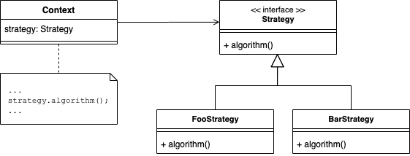

* **Strategy java example (Code Snippet)**

1. Algorithms Interface

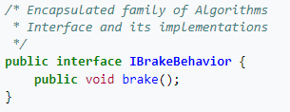

1. Algorithms classes

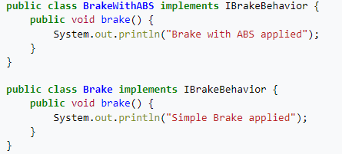

1. Class that changes algorithm

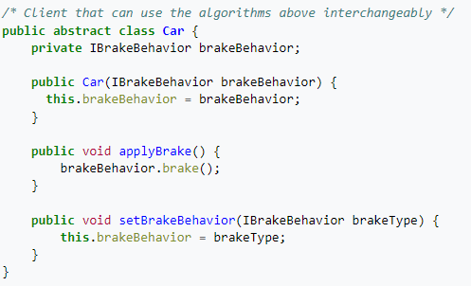

**Code location:**

The class is in the following path:

“*src\main\java\org\jabref\model\groups\WordKeywordGroup.java*”

* **Interface that all Algorithms implement**

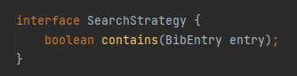

* 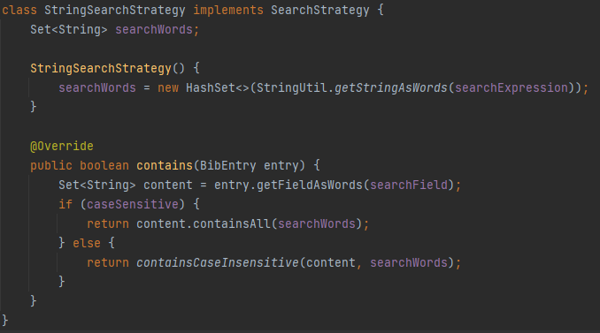**Algorithm One**
* 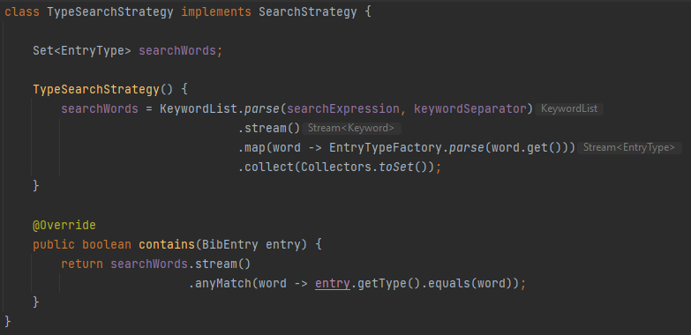**Algorithm Two**
* 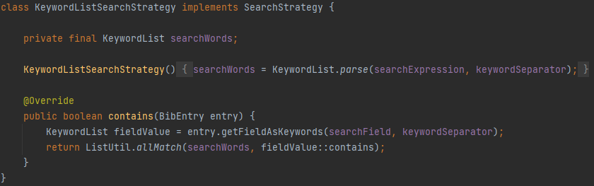**Algorithm Three**
* 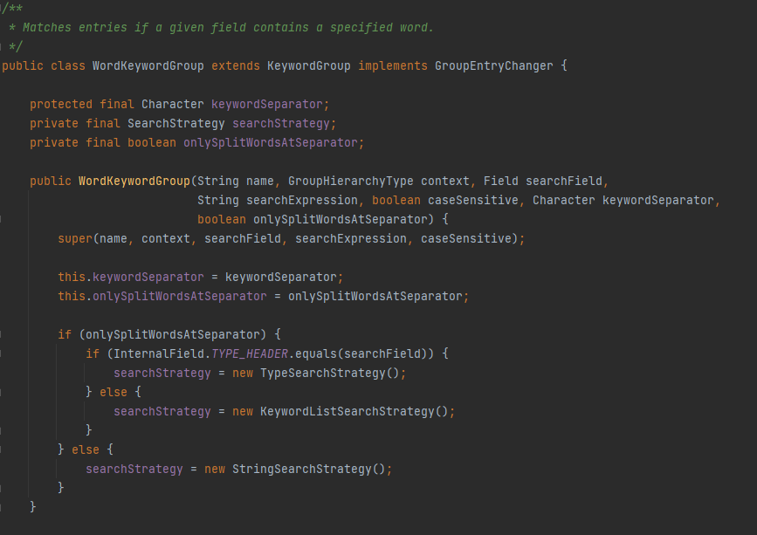**Class that chooses what algorithm should use**

(The variable searchStrategy is of type SearchStrategy, that means it’s the variable that saves the algorithm that should be used. At the end of the constructor\ , inside the if statement, the program choose what algorithm should use)

**Justification:**

Like we saw above exist a variable, which type is the interface that is implemented by all the algorithms. This variable is used to control what algorithm should be used by the program.